ANNUAL MEETING
Of
GREAT WITLEY & HILLHAMPTON PARISH
GREAT WITLEY VILLAGE HALL
7.30PM THURSDAY 17TH MAY 2018
Reports will be presented by the following:
- Chairman’s Report
- West Mercia Police Community Support Officer
- District Councillor Paul Cumming
- County Councillor Ken Pollock
- Great Witley Village Hall
- Great Witley Church
- Quarter Green
- Scouts & Cubs
- Guides & Brownies
- Great Witley Primary School
- Neighbourhood Plan Working Party
Following the reports there will be an open forum in which you are welcome to share any views or concerns that you may have with your fellow villagers and put any questions to your Parish Councillors

This year Charlie’s Bar will be available with the first ticketed drink free (wine/beer/soft) and for your entertainment we are very lucky to have Mr John Page, guest speaker, whose talk is entitled:
Life doesn't stop when you retire from your regular job.
When John retired from teaching he found that he had more time to properly engage with the world, both physically and intellectually. Since then he has travelled independently across 5 continents by his own, as well as mechanised, means of transport, he’s embraced the international world of the MOOC and researched and written about the vagaries of 17th century population crises within his beloved Yorkshire.
Next? South from Tallinn, Estonia by bike....as far as motivation and politicians allow him!
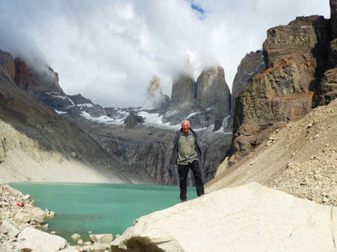

The photo was in Patagonia last year.
.

